Comparing Data Among Low Range Instruments
At this point, we’ve compared the frequency spectrum for many different recordings and ranges for low-range instruments. We found that there was a lot of variance in the data between identical models, specifically for the G string on the violin. This tracks with anecdotal claims, as one of the main distinguishing features between a cheap and quality violin is a rich tone on the G string.
Looking at the higher frequencies in our low-range instruments confirmed the hypothesis that there relatively detectable super-sonic activity in the higher frequency ranges. This was prevalent in both of the instruments on the open E harmonic recording, although the intensity of one of the instruments was significantly different compared to the other—this may be due to discrepancies in recording methodology and construction of the instrument.
In this section, we will perform a similar analysis for the higher price range instruments. This includes the Kono and John Cheng recordings. The same recordings that were covered in the previous section will be covered here as well, with the same general structure of comparison, to maintain consistency between our analyses.
We will first look at the Open G string recordings of the Kono and John Cheng. We will only look at the lower spectrum of this recording, as there is no relatively detectable super-sonic activity in the G string recordings. The two instruments’ lower spectrum can be seen overlaid in Figure 1.

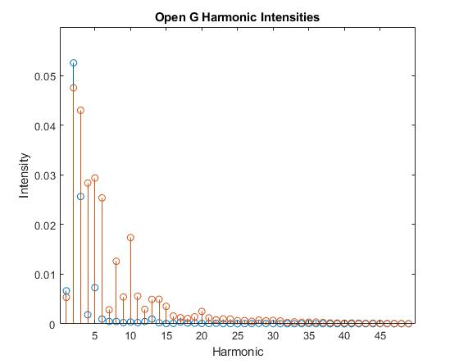
Figure 1: Open G Harmonic Intensities
The plot above shows the Kono’s spectrum plotted in blue and the Cheng’s spectrum plotted in orange. As expected, the two spectrums for the two instruments is wildly different. This is to be expected, as we noticed in the previous comparison section that the G string’s data was very different, even across identical models. Based on this, it makes sense that the data shows no correlation between instruments that are different.
It should be noted that the John Cheng, which is the cheaper of the two instruments, has two peaks of nearly equal intensity in the lower harmonics. The Kono has one distinguished peak at the second harmonic, followed by a sharp exponential decay leading into the higher harmonics. It would take a larger sample size to come to any solid conclusions, but a sharp exponential decay in the G string’s spectrum may be linked to richness in sound.
Next, we’ll look at the open A string’s spectrum for both instruments, examining only the lower frequencies. These plots can be seen in Figure 2.

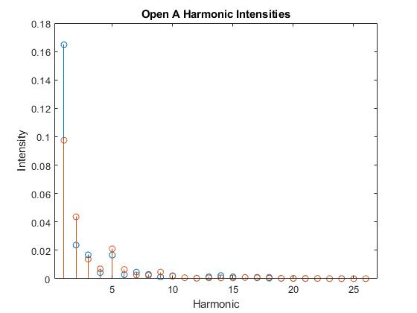
Figure 2: Open A Harmonic Intensities

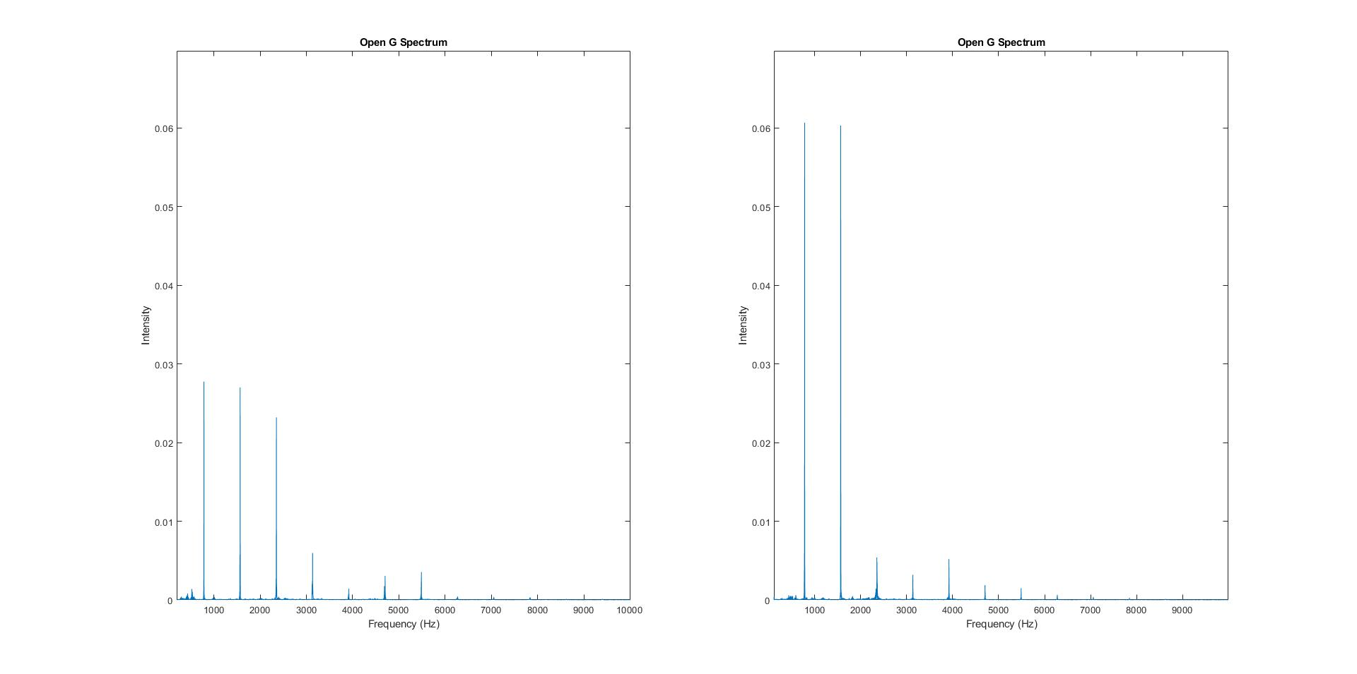
Figure 3: Open G Harmonic Spectrum

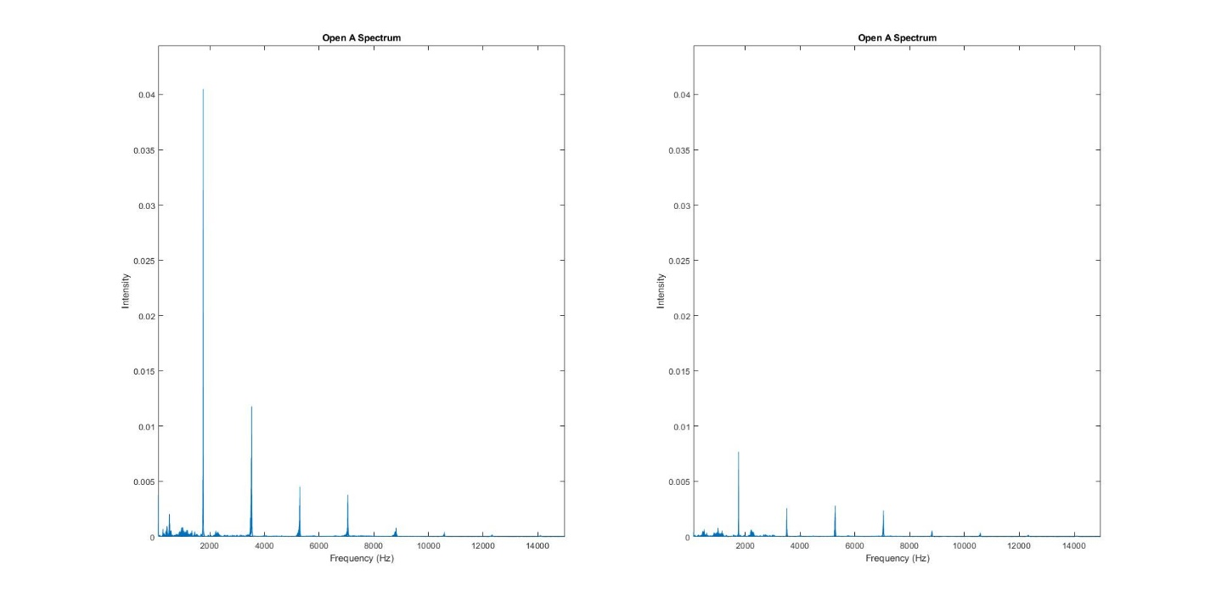
Figure 4: Open A Harmonic Spectrum

